REPORT

ACS Division of Chemical Health and Safety (CHAS)

Gen 2 Virtual Strategic Planning Retreat

September 6, 7, 11, 2023

CHAS Reasons for the Retreat

CHAS currently faces several challenges: a possible loss of members due to the separation of a divisional subgroup, member engagement issues, and clarity of their role amongst the various ACS chemical safety units. The CANN (cannabis) chemistry group within CHAS plans to become a separate division, resulting in an unknown decrease in members. Filling the volunteer pipeline for division positions is increasingly difficult. This is compounded by significant volunteer turnover. The ACS safety community works in silos and often with much redundancy and competition for resources.
Considering these challenges and although much has been accomplished on the previous Strategic Plan done in 2015, the leaders of CHAS felt it was time to consider a refresh of their plan to address the post pandemic environment and the resulting opportunities. Work was begun last year to review the division’s purposes and identify key strategic approaches to concentrate on for the next three-to-five-year period, but it was decided that development of a 2nd generation strategic plan via a Strategic Planning Retreat was needed, since the many opportunities available requiring development of actionable activities requires choosing a well-defined attainable focus.
Factors for consideration include divisional membership demographics, a strong financial position, currently successful programs, incorporation of newer programming, establishment of ‘best practices’, and modernization and upgrading of communications and infrastructure.

Strategic Planning Process

The ACS Strategic Planning Process was introduced via a slide deck to participants prior to the retreat to familiarize them with the process. Participants of the Virtual Strategic Planning Retreat (VSPR) and other involved CHAS colleagues were asked to complete pre-work to provide valuable input to use in helping craft the Gen 2 CHAS plan.
Ultimately, a CHAS strategic plan focused on the next three-to-five-year period was developed using this ACS strategic planning process, conducted during four virtual 3-hour sessions held on September 6 (2), 7, and 11, 2023.

A summary of the key elements is depicted in the one pager graphic below.

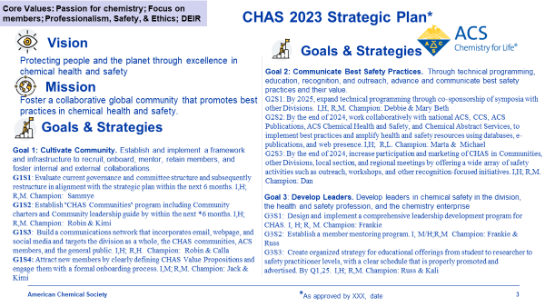

CHAS 2023 Strategic Plan

SPR Participants

Thirteen CHAS members participated in the four Zoom sessions. The VSPR Facilitators
were Carol Duane and Larry Krannich. A picture of the group from the Day 1 AM session is below.

First Name | Last Name | Email Address | Affiliation
Kimberly | Brown | Kimi.Brown127@gmail.com | SciShield
Debbie | Decker | debbie.m.decker@gmail.com | U. Cal. Davis (ret)
Marta | Gmurczyk* | M_Gmurczyk@acs.org | ACS Safety Programs
Robin | Izzo* | rmizzo@princeton.edu | Princeton U
Michael | Koehler* | mgkoehler@proaaci.com
Mary Beth | Koza* | mbkoza2@gmail.com | U. North Carolina (ret)
Daniel | Kuespert | dkuespert@pm.me | Johns Hopkins Univ.
Calla | McCulley | callamaemcculley@gmail.com | U. Michigan
Kali | Miller | kalim863@gmail.com
Monica | Nyansa** | mnyansa@mtu.edu | Michigan Tech U
Russ | Phifer | rphifer@wcenvironmental.com | W.C. Environmental
Jack | Reidy | jreidy2@stanford.edu | Stanford EHS
Sammye | Sigmann* | sigmannsb@skybest.com | Appalachian State U (ret)
Frankie | Wood-Black | fwoodblack90@gmail.com
*Participants in the Envisioning the Future of ACS Chemical Safety Exercise
** Attended one session

CHAS Group picture
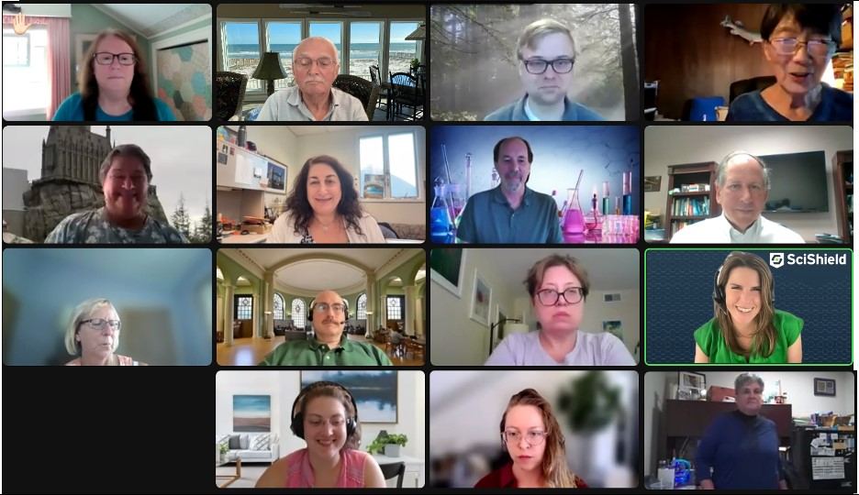
CHAS Participants: Sammye Sigmann, Larry Krannich (facilitator), Jack Reidy, Carol Duane (facilitator), Debbie Decker, Robin Izzo, Russ Phifer, Michael Koehler, Mary Beth Koza, Dan Kuespert, Marta Gmurczyk, Kimberly Brown, Calla McCulley, Kali Miller, Frankie Wood-Black

SPR Expectations

The participants were asked to introduce themselves and voice their expectations of the planning process, which when revisited at the end of the retreat were seen to have been addressed very well.

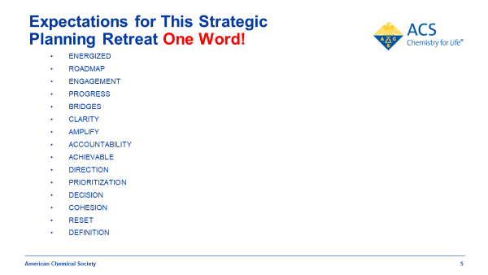

Gen 2 Strategic Planning Process

Facilitators presented an overview of the Strategic Planning process to be used for CHAS’ strategic plan development. The process follows the Society’s strategic plan as described at strategy.acs.org. The second-generation plan development process used is depicted in the graphic below:

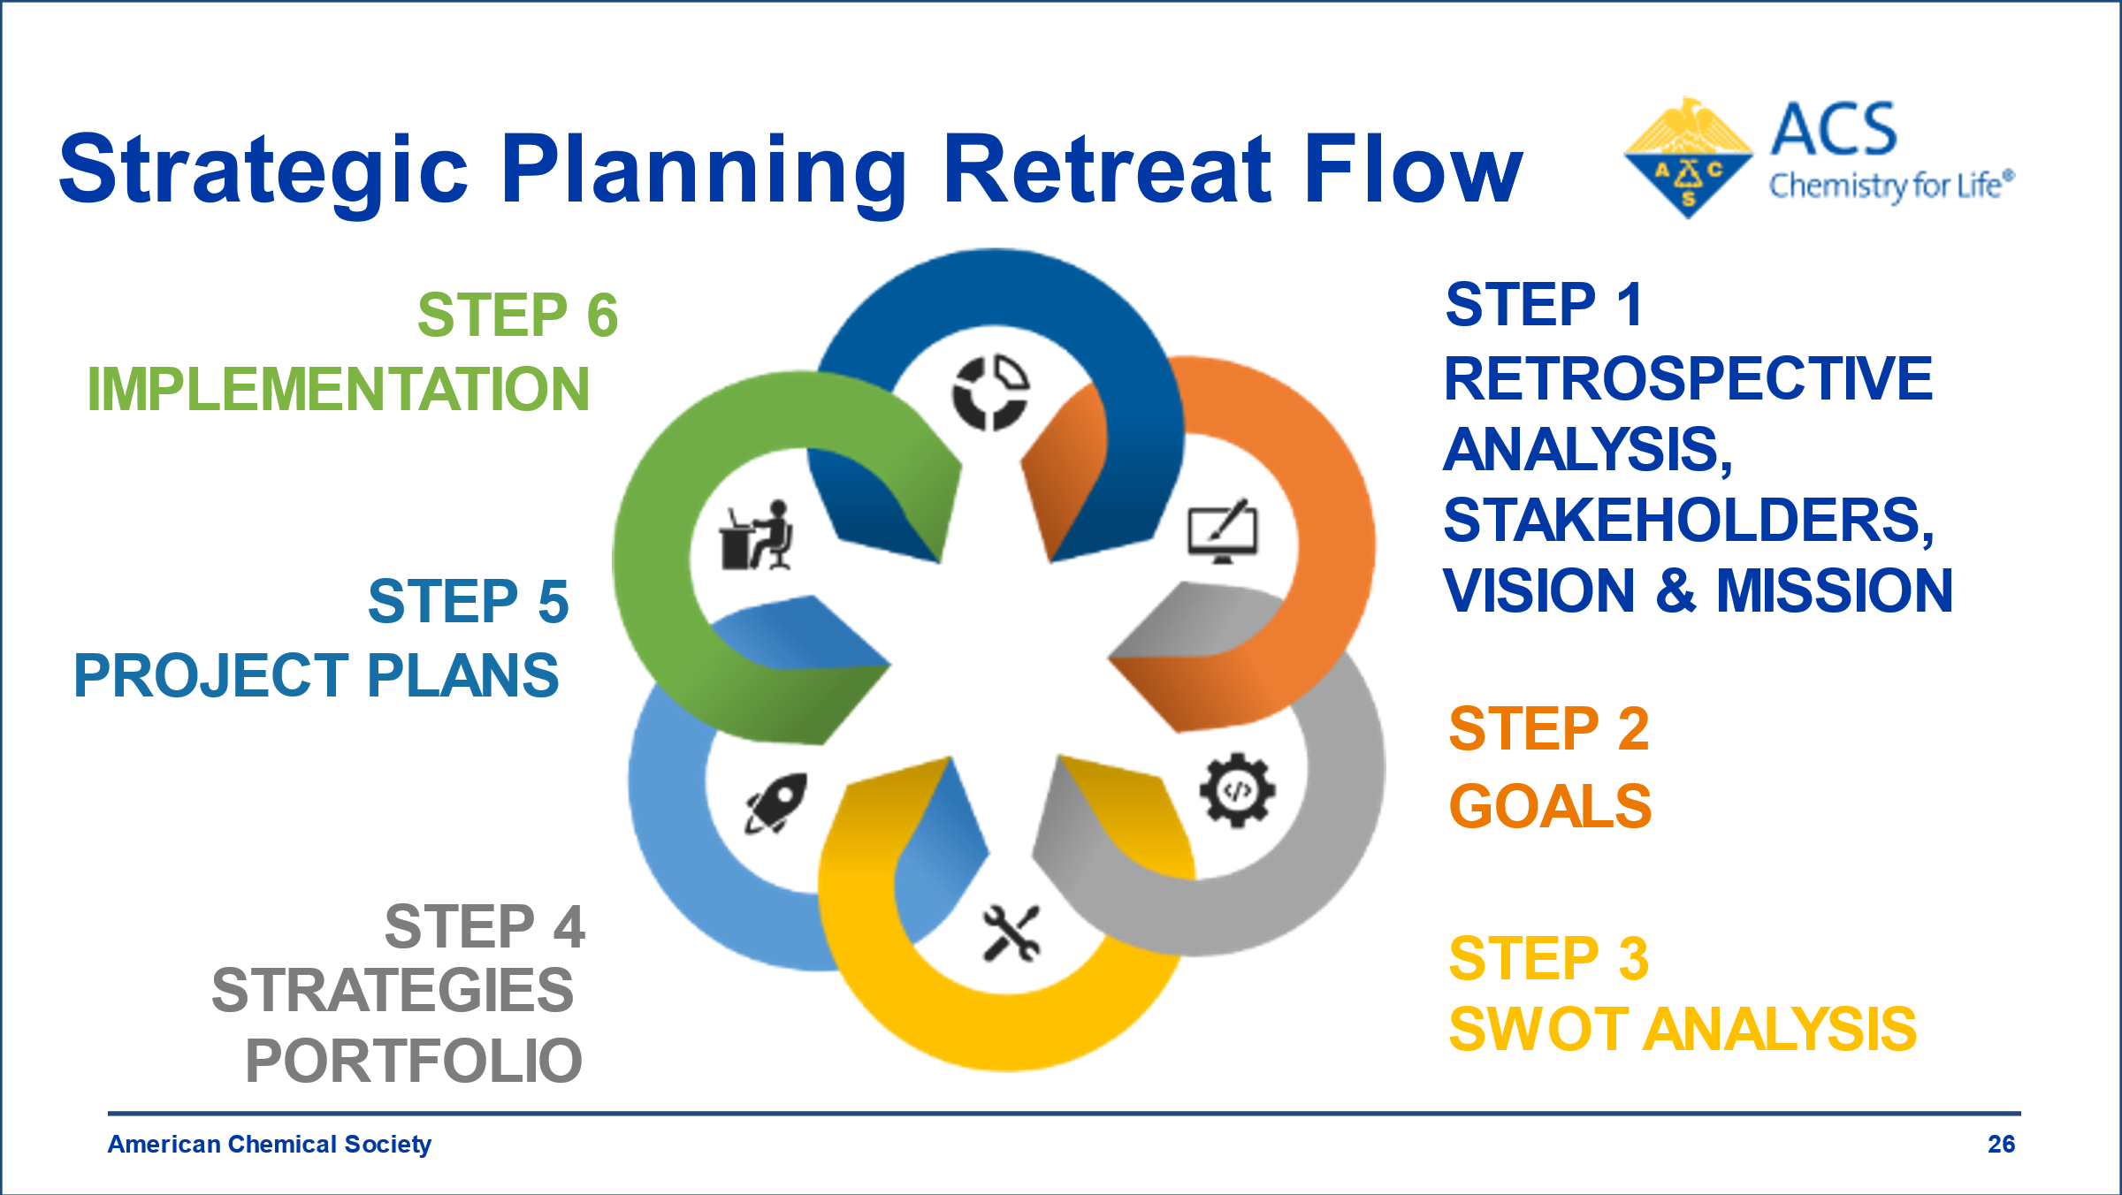

Retrospective Review

The planning process began with a review of the previous CHAS plan developed in 2015 and considered successes, ‘do betters’, and lessons learned for going forward. The 2015 Plan had established Vision and Mission statements and stated four Goals and 16 Goal/strategies. Of these strategies, seven were completed and seven were noted as possible carry forward approaches. Most of the comments on what to do going forward centered on narrowing the focus and improving management of the implementation, indicating that some of these strategic activities could align with the future focus.

Stakeholder Analysis

Next the group held a Stakeholder discussion to aid in reviewing and confirming the Vision and Mission statements. In the prework, these groups were identified as CHAS stakeholders:
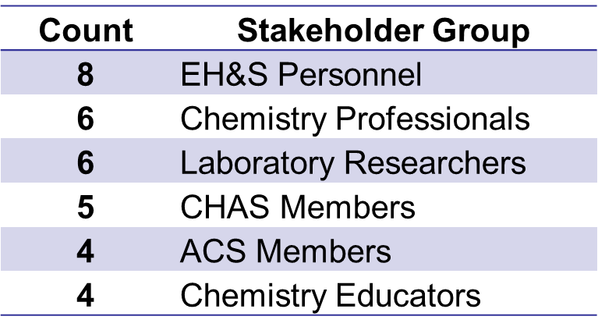

A lengthy and considered discussion of the composition of the stakeholder groups identified in the prework clarified the organizations and individuals comprising these groups. As a member organization CHAS Members were specified as the stakeholders of most importance, i.e. highest interest and where the most direct influence could occur. It was noted that some of the other named stakeholder groups could comprise both CHAS members or non-members and clarity on the constituencies in these categories was defined. Realizing that stakeholders could also be aspirational, several groups were more specifically described and a couple of other stakeholders were added. The final agreed list of key Stakeholders and their Priority is in the graphic below.

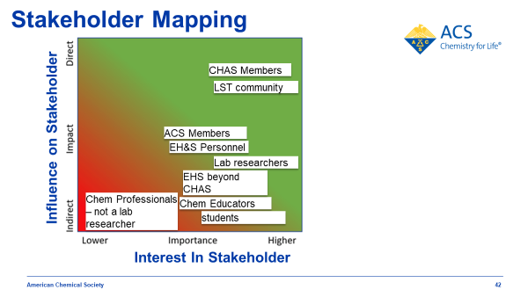

Vision Statement

The group reviewed best practices for vision statements, examples from other ACS committees and the results of the prework survey. After discussion and informed by the in-depth stakeholder considerations, it was confirmed that the existing Vision statement: Improving people’s lives through the power of best chemical health and safety practices, while valid would benefit from a revised rewording and they agreed on a more powerful statement:

CHAS Vision Statement, as of September 2023:

Protecting people and the planet through excellence in chemical health and safety.

Mission Statement

Following a similar review process, the group refined the CHAS mission statement, aligning to the new CHAS vision statement. It was agreed that the following statement depicts the role of CHAS and ultimately enables the members to achieve the vision.

CHAS Mission Statement, as of September 2023:

Foster a collaborative global community that promotes best practices in chemical health and safety.

Goals

Next, Goals for the next three-to-five-year period were considered. In the prework the 2015 goals were reviewed, and goal theme ideas were solicited. With the vision & mission confirmed and restated, consideration of these pre-work and other ideas and discussion of alignment to the mission, led to three goal areas for focus in the near term: Cultivate community, Communicate Best safety Practices, and Develop Leaders.

Valuable small group discussions, with full group input, were held in Mural to refine these focus areas into clear statements to direct CHAS efforts over the next 3-5 years:

GOAL 1: Cultivate Community. Establish and implement a framework and infrastructure to recruit, onboard, mentor, retain members, and foster internal and external collaborations.

GOAL 2. Communicate Best Safety Practices. Through technical programming, education, recognition, and outreach, advance and communicate best safety practices and their value.

GOAL 3: Develop Leaders. Develop leaders in chemical safety in the Division, the health and safety profession, and the chemistry enterprise.

SWOT Analysis

The ACS 2020 change drivers, along with a scan of trends internal and external to ACS, formed the basis for developing the CHAS 2023 SWOT analysis, including identifying threats and opportunities for CHAS amongst these trends and noting correlation of these with CHAS strengths and weaknesses, using the SWOT analysis.
Key threats and opportunities for CHAS were correlated with key strengths and weaknesses of the committee to identify Enablers and Challenges to achieving CHAS goals.

Goal/Strategies (SMARTIE)

Ideas for implementing each of the goals were brainstormed by group members, posted in Alchemer, and collated by the facilitators. Group members then categorized and prioritized those strategies to implement in the first year or two of the strategic plan. The top 3-4 strategy categories for each goal were described in SMARTIE strategy statements within breakout groups. The SMARTIE strategies were reviewed by the full group and amended by consensus, as needed. Impact and Resources required were added and a champion and/or co-champions for each strategy were designated. (The complete list of brainstormed strategies is included as a pdf attachment: CHAS Strategy Portfolio 2G_2023-09-07_19-26-15).

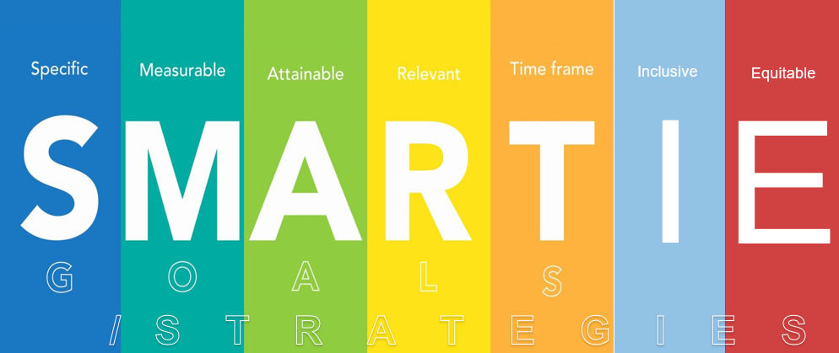

CHAS Goals/Strategies Portfolio:

Goal 1: Cultivate Community. Establish and implement a framework and infrastructure to recruit, onboard, mentor, retain members, and foster internal and external collaborations.

G1S1: Evaluate current governance and committee structure and subsequently restructure in alignment with the strategic plan within the next 6 months. I,H; R,M. Champion: Sammye

G1S2: Establish "CHAS Communities" program including Community charters and Community leadership guide by within the next *6 months. I,H; R,M. Champion: Robin & Kimi

G1S3: Build a communications network that incorporates email, webpage, and social media and targets the division as a whole, the CHAS communities, ACS members, and the general public. I,H; R,H. Champion: Robin & Calla

G1S4: Attract new members by clearly defining CHAS Value Propositions and engage them with a formal onboarding process. I,M; R,M. Champion: Jack & Kimi

Goal 2: Communicate Best Safety Practices. Through technical programming, education, recognition, and outreach, advance and communicate best safety practices and their value.

G2S1: By 2025, expand technical programming through co-sponsorship of symposia with other Divisions. I,H; R,M. Champion: Debbie & Mary Beth

G2S2: By the end of 2024, work collaboratively with national ACS, CCS, ACS Publications, ACS Chemical Health and Safety, and Chemical Abstract Services, to implement best practices and amplify health and safety resources using databases, e-publications, and web presence. I,H; R,L. Champion: Marta & Michael

G2S3: By the end of 2024, increase participation and marketing of CHAS in Communities, other Divisions, local section, and regional meetings by offering a wide array of safety activities such as outreach, workshops, and other recognition-focused initiatives. I,H; R,M. Champion: Dan

Goal 3: Develop Leaders. Develop leaders in chemical safety in the division, the health and safety profession, and the chemistry enterprise.

G3S1: Design and implement a comprehensive leadership development program for CHAS. I, H; R, M. Champion: Frankie

G3S2: Establish a member mentoring program. I, M/H;R,M Champion: Frankie & Russ

G3S3: Create organized strategy for educational offerings from student to researcher to safety practitioner levels, with a clear schedule that is properly promoted and advertised. By Q1,25. I,H; R,M. Champion: Russ & Kali

The Goal-strategies were plotted on the Opportunity Map and it was noted that G2S2 lies in the “No Brainer” quadrant, which would be a good use of group resources. Most of the strategies fall on the line between the “No Brainer” and “Pursue Selectively” quadrants. It was noted that in developing the schedule for implementation of the project plans for the strategies, it will be important to coordinate the timing and integrate the resource plans of the strategies for best success. Implementation of some of the low hanging fruit would jump start the strategic plan and create energy and momentum going forward.

CHAS Goals/Strategies Opportunity Map:

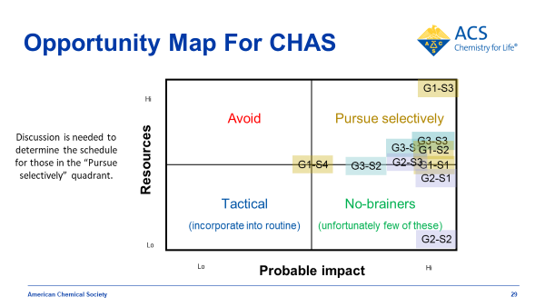

Plan and Project Champions for Goals/Strategies:

Participants self-selected as Champion or co-champion for each strategy. Their first responsibility was to draft a project plan to begin implantation of the activity and suggest appropriate team leaders and members. The responsibility for plan oversight was delegated to the Chair succession.

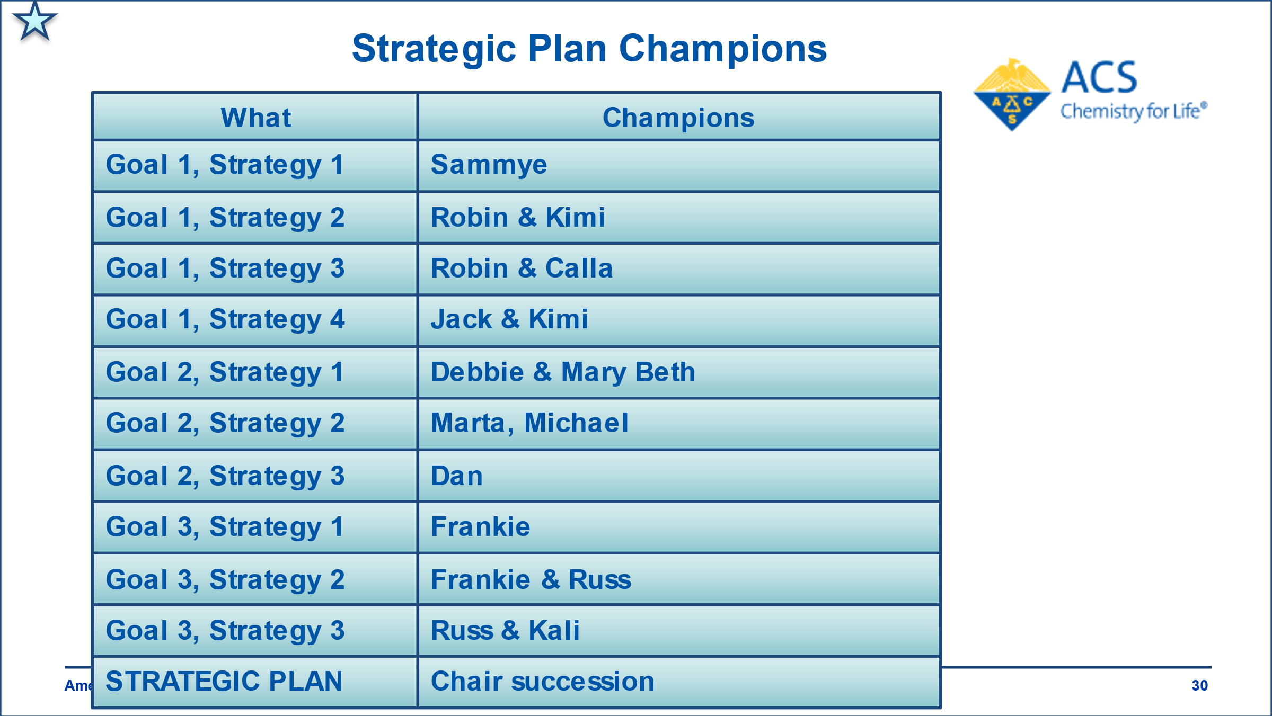

XIII: Moving Forward and Ensuring Success with the Strategic Plan

Draft Project Plans:

At the end of Session 3, the champions were assigned to draft a project plan for each strategy using the Excel spreadsheet provided. A brief discussion of project metrics was held prior to this, and the facilitators noted that determining success metrics and the tools for tracking them at the beginning of a project is critical. During Session 4, a debrief of the draft project plans was held. Each champion and or co-champion presented the salient points of the project and received feedback on achievability and feasibility of the outcomes and timelines. Discussion of the plans pointed out synergistic interconnectivity and all agreed that ongoing planning should be coordinated to avoid duplication of activity, enhance collaborative impact, and integrate timelines appropriately. Particular emphasis was placed on needing to develop an overall timeline, so as not to stretch resources too thinly. This rich dialogue allowed the entire team to contribute to each plan.
In the discussion, it was noted that Goal/strategy G2S3 needed further focusing to draft the action plan. It was also noted that the draft project plans for G3S1 and G3S2 required further consideration. The group agreed that a post retreat discussion should address these strategies and project plans. Suggestions were inserted as yellow highlighted steps with others indicated in the notes section of the project plan template.

General Pitfalls:

Facilitators noted common implementation pitfalls and emphasized the opportunity to engage fellow CHAS members and new volunteers in the implementation, the need to establish an accountability system to stay on track and measure progress, and the value of recognizing successes to maintain motivation. It cannot be over-emphasized what a great opportunity CHAS has in being able to use this newly developed strategic plan to reach out to new partners and to collaborate through the chemical health and safety envisioning group. Having a clear task request makes it easier to ask people to help – and easier for them to agree.

Next Steps

An overall Strategic Planning project timeline detailing these and other next steps was highly recommended by the facilitators. Within the individual project plans presented, the different tasks could be broken out as smaller steps by the engaged project team members, so that these strategies can most effectively use the division resources. This also allows for the implementation of clear metrics.

A CHAS central repository will be established in Basecamp, which will be used for project plans and strategic planning materials, along with the other centralized materials for CHAS such as a recent division member survey and the Envisioning Future of Safety Report.

CHAS Next Steps:

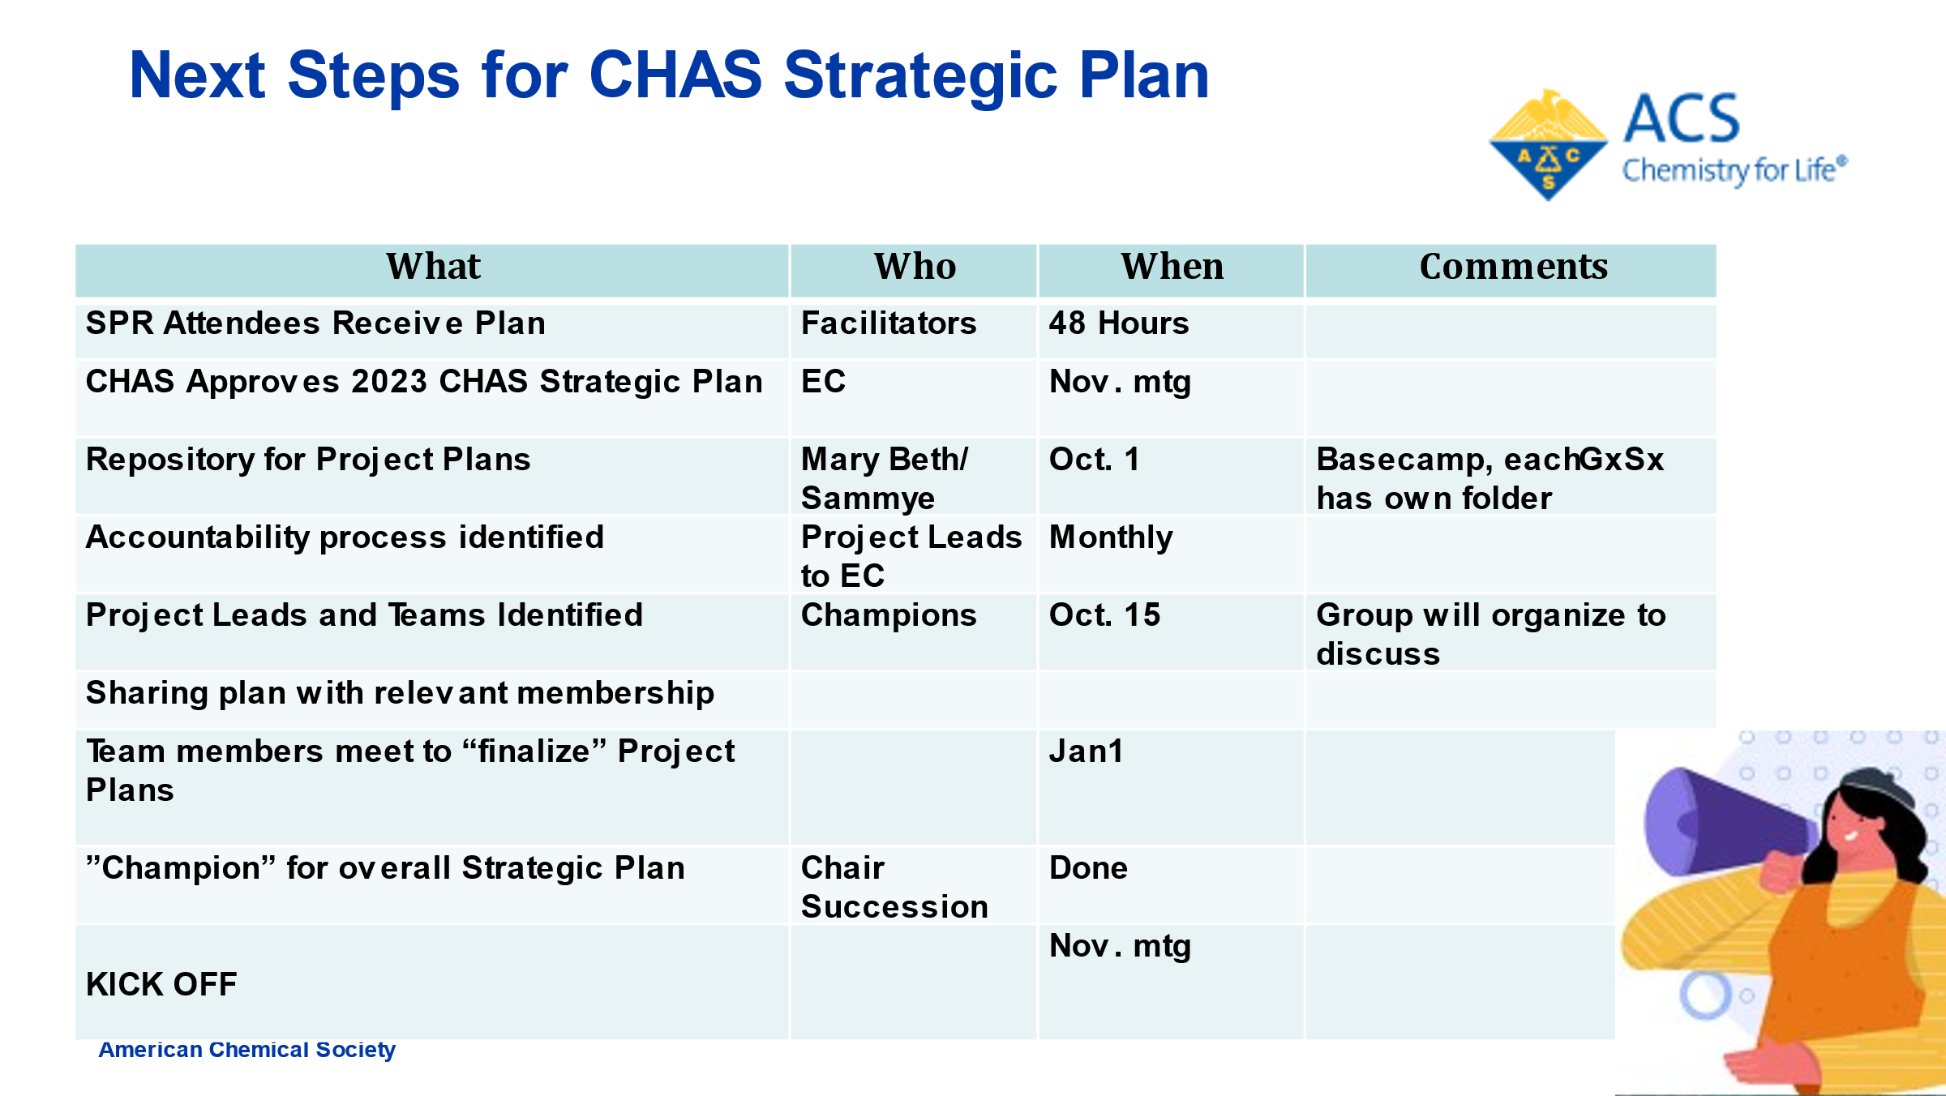

Plus/Deltas for the CHAS SPR:

Facilitators asked for feedback on the highlights of the virtual retreat and suggestions for future retreats, as noted in the graphic below.

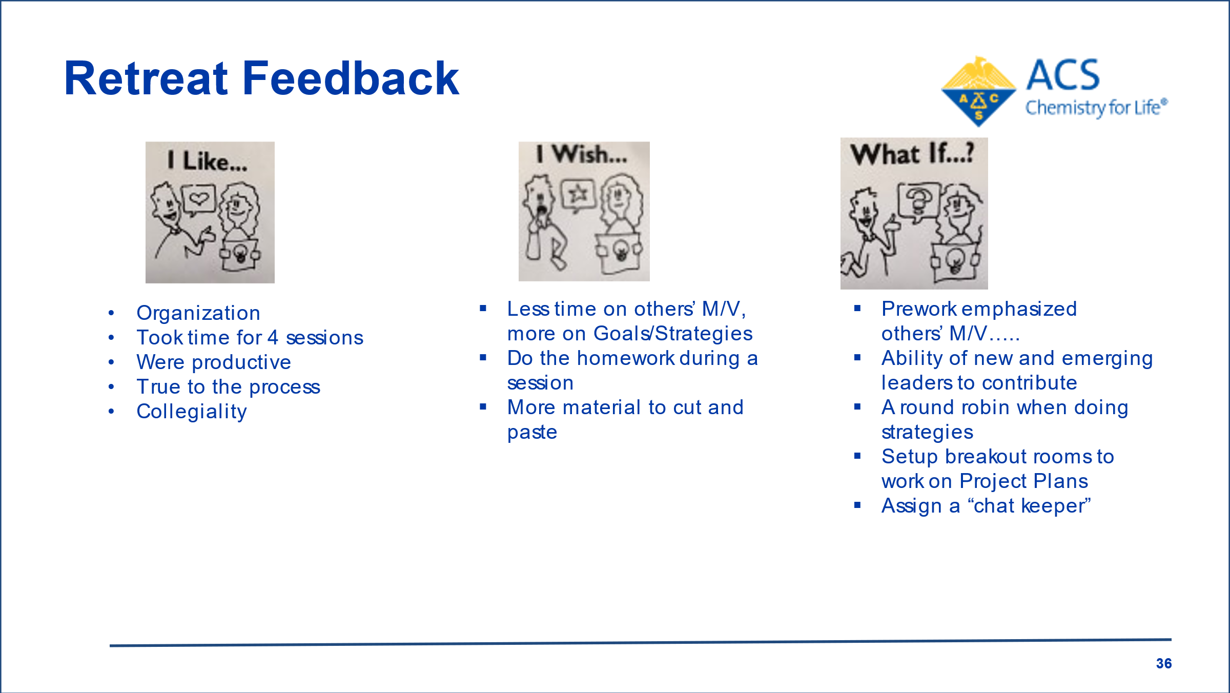

Additional Resources Available

The Excel project plan template workbook used by the champions provides some project management tools.
Here are links to resources on:
-How to make a timeline in Power Point
https://www.officetimeline.com/make-timeline/powerpoint#manually-make-powerpoint

-How to make a timeline in Excel
https://www.officetimeline.com/make-timeline/excel

-How to make a Gannt chart in 3 minutes
Gantt Chart Excel Tutorial - How to make a Basic Gantt Chart in Microsoft Excel 2016
-If you are interested in a quick overview of Project Management (PM), please take the self-directed Project Management 101 available at:
https://www.dropbox.com/s/849vsed03a3avgz/Project%20Management%20101%20FINAL.pdf?dl=0
Encourage your Project Leads and Teams to take Project Management 101; which emphasizes the 5 basic phases of PM
-If you or others are interested in a more detailed or in-depth treatment of Project Management, please see:
https://www.dropbox.com/s/s1y55lrk7wuu6pi/PROJECT%20MANAGEMENT%20FOR%20THE.%20NONPROFESSIONAL%20PM.pdf?dl=0

Note: Separate attachments:
- The strategic plan and other key graphics are included as a separate presentation file with this final report.
- The Excel workbook with all Goal/strategy project plans
- PDFs of the Mural Goals and Strategies breakout room work
- Chat notes from the retreat sessions.

